**Laporan Praktikum**

**Bahasa Pemrograman 1**

**Dosen pengampu : (*Dede Husen, M.Kom.*)**

# Modul 3



**Nama : Muhammad Rizal Nurfirdaus**

**NIM : 20230810088**

**Kelas : TINFC – 2023 – 04**

**Teknik Informatika Fakultas Ilmu Komputer**

**Universitas Kuningan**

# Pre Test

1. Apa itu Swing?
2. Apa fungsi dari Swing?
3. Tuliskan contoh program sederhana untuk Swing container dan menu!

**Praktikum**

1. **BP1_M3_P1_Rizal_Container**

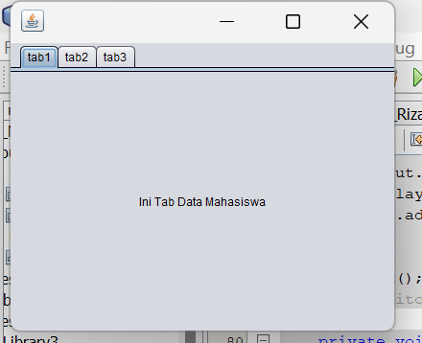

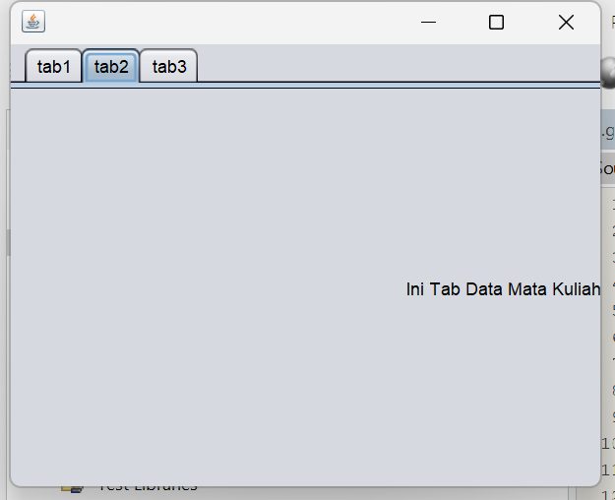

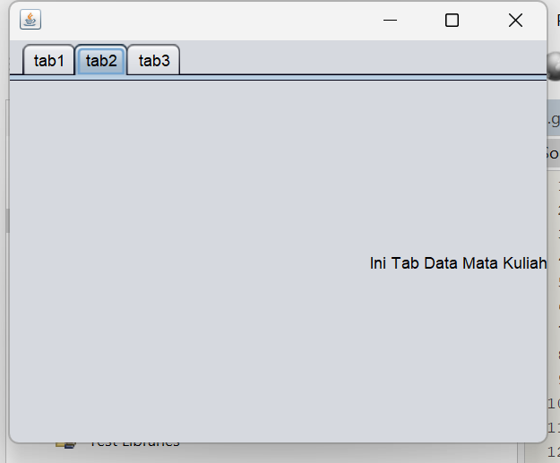

**Script Code :** /*

import javax.swing.JOptionPane;

/*

* To change this license header, choose License Headers in Project Properties.

* To change this template file, choose Tools | Templates

* and open the template in the editor.

*/

/**

*

* @author Muhammad Rizal Nur F

*/

public class BP1_M3_P1_Rizal_Container extends javax.swing.JFrame {

/**

* Creates new form BP1_M3_P1_Rizal_Container

*/

public BP1_M3_P1_Rizal_Container() {

initComponents();

}

/**

* This method is called from within the constructor to initialize the form.

* WARNING: Do NOT modify this code. The content of this method is always

* regenerated by the Form Editor.

*/

@SuppressWarnings("unchecked")

// <editor-fold defaultstate="collapsed" desc="Generated Code">

private void initComponents() {

jTabbedPane1 = new javax.swing.JTabbedPane();

jLabel1 = new javax.swing.JLabel();

jLabel2 = new javax.swing.JLabel();

jLabel3 = new javax.swing.JLabel();

setDefaultCloseOperation(javax.swing.WindowConstants.EXIT_ON_CLOSE);

jLabel1.setHorizontalAlignment(javax.swing.SwingConstants.CENTER);

jLabel1.setText("Ini Tab Data Mahasiswa");

jLabel1.addMouseListener(new java.awt.event.MouseAdapter() {

public void mouseClicked(java.awt.event.MouseEvent evt) {

jLabel1MouseClicked(evt);

}

});

jTabbedPane1.addTab("tab1", jLabel1);

jLabel2.setHorizontalAlignment(javax.swing.SwingConstants.RIGHT);

jLabel2.setText("Ini Tab Data Mata Kuliah");

jLabel2.addMouseListener(new java.awt.event.MouseAdapter() {

public void mouseClicked(java.awt.event.MouseEvent evt) {

jLabel2MouseClicked(evt);

}

});

jTabbedPane1.addTab("tab2", jLabel2);

jLabel3.setHorizontalAlignment(javax.swing.SwingConstants.LEFT);

jLabel3.setText("Ini Tab Data Nilai");

jLabel3.addMouseListener(new java.awt.event.MouseAdapter() {

public void mouseClicked(java.awt.event.MouseEvent evt) {

jLabel3MouseClicked(evt);

}

});

jTabbedPane1.addTab("tab3", jLabel3);

javax.swing.GroupLayout layout = new javax.swing.GroupLayout(getContentPane());

getContentPane().setLayout(layout);

layout.setHorizontalGroup(

layout.createParallelGroup(javax.swing.GroupLayout.Alignment.LEADING)

.addComponent(jTabbedPane1, javax.swing.GroupLayout.DEFAULT_SIZE, 400, Short.MAX_VALUE)

);

layout.setVerticalGroup(

layout.createParallelGroup(javax.swing.GroupLayout.Alignment.LEADING)

.addComponent(jTabbedPane1, javax.swing.GroupLayout.DEFAULT_SIZE, 300, Short.MAX_VALUE)

);

pack();

}// </editor-fold>

private void jLabel1MouseClicked(java.awt.event.MouseEvent evt) {

// TODO add your handling code here:

JOptionPane.showMessageDialog(null,"Ini tab Data Mahasiswa", "Informasi", JOptionPane .INFORMATION_MESSAGE);

}

private void jLabel2MouseClicked(java.awt.event.MouseEvent evt) {

// TODO add your handling code here:

int close = JOptionPane.showOptionDialog(this, "Ini tab Data Mata Kuliah! Keluar Aplikasi","YesNoOption", JOptionPane.YES_NO_OPTION, JOptionPane.QUESTION_MESSAGE, null, null, null);

if(close == JOptionPane.YES_OPTION){

this.dispose();

}

}

private void jLabel3MouseClicked(java.awt.event.MouseEvent evt) {

// TODO add your handling code here:

JOptionPane.showMessageDialog(null,"Ini tab Data Mahasiswa", "Informasi", JOptionPane .ERROR_MESSAGE);

}

/**

* @param args the command line arguments

*/

public static void main(String args[]) {

/* Set the Nimbus look and feel */

//<editor-fold defaultstate="collapsed" desc=" Look and feel setting code (optional) ">

/* If Nimbus (introduced in Java SE 6) is not available, stay with the default look and feel.

* For details see http://download.oracle.com/javase/tutorial/uiswing/lookandfeel/plaf.html

*/

try {

for (javax.swing.UIManager.LookAndFeelInfo info : javax.swing.UIManager.getInstalledLookAndFeels()) {

if ("Nimbus".equals(info.getName())) {

javax.swing.UIManager.setLookAndFeel(info.getClassName());

break;

}

}

} catch (ClassNotFoundException ex) {

java.util.logging.Logger.getLogger(BP1_M3_P1_Rizal_Container.class.getName()).log(java.util.logging.Level.SEVERE, null, ex);

} catch (InstantiationException ex) {

java.util.logging.Logger.getLogger(BP1_M3_P1_Rizal_Container.class.getName()).log(java.util.logging.Level.SEVERE, null, ex);

} catch (IllegalAccessException ex) {

java.util.logging.Logger.getLogger(BP1_M3_P1_Rizal_Container.class.getName()).log(java.util.logging.Level.SEVERE, null, ex);

} catch (javax.swing.UnsupportedLookAndFeelException ex) {

java.util.logging.Logger.getLogger(BP1_M3_P1_Rizal_Container.class.getName()).log(java.util.logging.Level.SEVERE, null, ex);

}

//</editor-fold>

/* Create and display the form */

java.awt.EventQueue.invokeLater(new Runnable() {

public void run() {

new BP1_M3_P1_Rizal_Container().setVisible(true);

}

});

}

// Variables declaration - do not modify

private javax.swing.JLabel jLabel1;

private javax.swing.JLabel jLabel2;

private javax.swing.JLabel jLabel3;

private javax.swing.JTabbedPane jTabbedPane1;

// End of variables declaration

}

**Analisis :**

Program Java di atas adalah sebuah applet yang menampilkan teks "Ayooo Belajar Java Applet" di tengah layar dengan font "Comic Sans MS" berukuran 20, berwarna merah, dan bergaya tebal.

**Penjelasan tentang kode:**

* **Kelas BP1_M2_P1_Rizal** memperluas Applet.
* **Metode init()** untuk inisialisasi, tapi kosong di sini.
* **Metode paint(Graphics g)** digunakan untuk menggambar teks:
  + Font diatur ke "Comic Sans MS" dengan warna merah.
  + Posisi teks dihitung agar tampil di tengah layar applet.

**Hasil ketika dijalankan:** Teks ditampilkan di tengah layar applet dengan gaya yang telah ditentukan.

1. BP1_M3_P2_Rizal  
   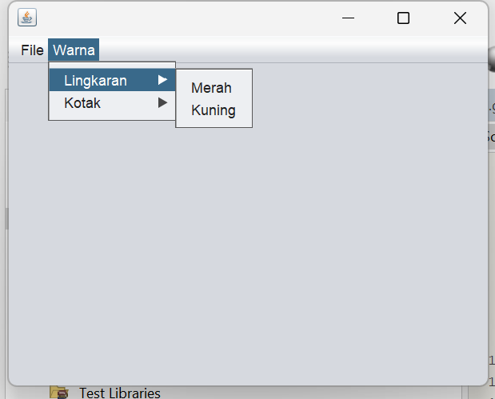

Script Code :  
/*

* To change this license header, choose License Headers in Project Properties.

* To change this template file, choose Tools | Templates

* and open the template in the editor.

*/

/**

*

* @author Muhammad Rizal Nur F

*/

public class BP1_M3_P2_Rizal extends javax.swing.JFrame {

/**

* Creates new form BP1_M3_P2_Rizal

*/

public BP1_M3_P2_Rizal() {

initComponents();

}

/**

* This method is called from within the constructor to initialize the form.

* WARNING: Do NOT modify this code. The content of this method is always

* regenerated by the Form Editor.

*/

@SuppressWarnings("unchecked")

// <editor-fold defaultstate="collapsed" desc="Generated Code">

private void initComponents() {

jMenuBar1 = new javax.swing.JMenuBar();

jMenu1 = new javax.swing.JMenu();

jMenuItem1 = new javax.swing.JMenuItem();

jMenuItem2 = new javax.swing.JMenuItem();

jMenu2 = new javax.swing.JMenu();

jMenu4 = new javax.swing.JMenu();

jMenuItem3 = new javax.swing.JMenuItem();

jMenuItem6 = new javax.swing.JMenuItem();

jMenu5 = new javax.swing.JMenu();

jMenuItem4 = new javax.swing.JMenuItem();

jMenuItem5 = new javax.swing.JMenuItem();

setDefaultCloseOperation(javax.swing.WindowConstants.EXIT_ON_CLOSE);

jMenu1.setText("File");

jMenuItem1.setText("Buka");

jMenu1.add(jMenuItem1);

jMenuItem2.setText("Simpan");

jMenu1.add(jMenuItem2);

jMenuBar1.add(jMenu1);

jMenu2.setText("Warna");

jMenu4.setText("Lingkaran");

jMenuItem3.setText("Merah");

jMenuItem3.addActionListener(new java.awt.event.ActionListener() {

public void actionPerformed(java.awt.event.ActionEvent evt) {

jMenuItem3ActionPerformed(evt);

}

});

jMenu4.add(jMenuItem3);

jMenuItem6.setText("Kuning");

jMenuItem6.addActionListener(new java.awt.event.ActionListener() {

public void actionPerformed(java.awt.event.ActionEvent evt) {

jMenuItem6ActionPerformed(evt);

}

});

jMenu4.add(jMenuItem6);

jMenu2.add(jMenu4);

jMenu5.setText("Kotak");

jMenuItem4.setText("Merah");

jMenu5.add(jMenuItem4);

jMenuItem5.setText("Biru");

jMenuItem5.addActionListener(new java.awt.event.ActionListener() {

public void actionPerformed(java.awt.event.ActionEvent evt) {

jMenuItem5ActionPerformed(evt);

}

});

jMenu5.add(jMenuItem5);

jMenu2.add(jMenu5);

jMenuBar1.add(jMenu2);

setJMenuBar(jMenuBar1);

javax.swing.GroupLayout layout = new javax.swing.GroupLayout(getContentPane());

getContentPane().setLayout(layout);

layout.setHorizontalGroup(

layout.createParallelGroup(javax.swing.GroupLayout.Alignment.LEADING)

.addGap(0, 400, Short.MAX_VALUE)

);

layout.setVerticalGroup(

layout.createParallelGroup(javax.swing.GroupLayout.Alignment.LEADING)

.addGap(0, 269, Short.MAX_VALUE)

);

pack();

}// </editor-fold>

private void jMenuItem3ActionPerformed(java.awt.event.ActionEvent evt) {

// TODO add your handling code here:

}

private void jMenuItem6ActionPerformed(java.awt.event.ActionEvent evt) {

// TODO add your handling code here:

}

private void jMenuItem5ActionPerformed(java.awt.event.ActionEvent evt) {

// TODO add your handling code here:

}

/**

* @param args the command line arguments

*/

public static void main(String args[]) {

/* Set the Nimbus look and feel */

//<editor-fold defaultstate="collapsed" desc=" Look and feel setting code (optional) ">

/* If Nimbus (introduced in Java SE 6) is not available, stay with the default look and feel.

* For details see http://download.oracle.com/javase/tutorial/uiswing/lookandfeel/plaf.html

*/

try {

for (javax.swing.UIManager.LookAndFeelInfo info : javax.swing.UIManager.getInstalledLookAndFeels()) {

if ("Nimbus".equals(info.getName())) {

javax.swing.UIManager.setLookAndFeel(info.getClassName());

break;

}

}

} catch (ClassNotFoundException ex) {

java.util.logging.Logger.getLogger(BP1_M3_P2_Rizal.class.getName()).log(java.util.logging.Level.SEVERE, null, ex);

} catch (InstantiationException ex) {

java.util.logging.Logger.getLogger(BP1_M3_P2_Rizal.class.getName()).log(java.util.logging.Level.SEVERE, null, ex);

} catch (IllegalAccessException ex) {

java.util.logging.Logger.getLogger(BP1_M3_P2_Rizal.class.getName()).log(java.util.logging.Level.SEVERE, null, ex);

} catch (javax.swing.UnsupportedLookAndFeelException ex) {

java.util.logging.Logger.getLogger(BP1_M3_P2_Rizal.class.getName()).log(java.util.logging.Level.SEVERE, null, ex);

}

//</editor-fold>

/* Create and display the form */

java.awt.EventQueue.invokeLater(new Runnable() {

public void run() {

new BP1_M3_P2_Rizal().setVisible(true);

}

});

}

// Variables declaration - do not modify

private javax.swing.JMenu jMenu1;

private javax.swing.JMenu jMenu2;

private javax.swing.JMenu jMenu4;

private javax.swing.JMenu jMenu5;

private javax.swing.JMenuBar jMenuBar1;

private javax.swing.JMenuItem jMenuItem1;

private javax.swing.JMenuItem jMenuItem2;

private javax.swing.JMenuItem jMenuItem3;

private javax.swing.JMenuItem jMenuItem4;

private javax.swing.JMenuItem jMenuItem5;

private javax.swing.JMenuItem jMenuItem6;

// End of variables declaration

}

**Post Test**

1. **BP1_M3_PostTest1_Rizal_**

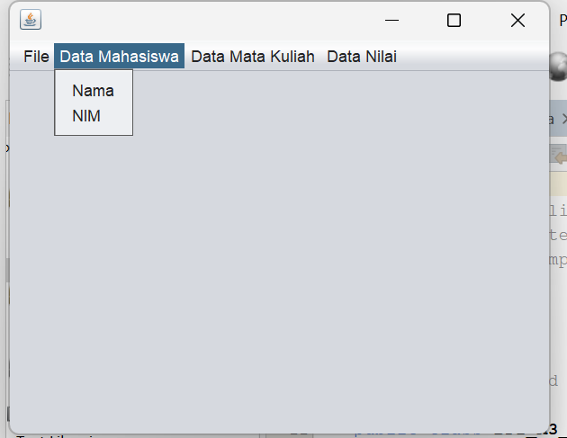

**Script Code :**

/*

* To change this license header, choose License Headers in Project Properties.

* To change this template file, choose Tools | Templates

* and open the template in the editor.

*/

/**

*

* @author Muhammad Rizal Nur F

*/

public class BP1_M3_PostTest1_Rizal extends javax.swing.JFrame {

/**

* Creates new form BP1_M3_PostTest1_Rizal

*/

public BP1_M3_PostTest1_Rizal() {

initComponents();

}

/**

* This method is called from within the constructor to initialize the form.

* WARNING: Do NOT modify this code. The content of this method is always

* regenerated by the Form Editor.

*/

@SuppressWarnings("unchecked")

// <editor-fold defaultstate="collapsed" desc="Generated Code">

private void initComponents() {

jMenuBar1 = new javax.swing.JMenuBar();

jMenu1 = new javax.swing.JMenu();

jMenuItem1 = new javax.swing.JMenuItem();

jMenuItem2 = new javax.swing.JMenuItem();

jMenu2 = new javax.swing.JMenu();

jMenuItem3 = new javax.swing.JMenuItem();

jMenuItem4 = new javax.swing.JMenuItem();

jMenu3 = new javax.swing.JMenu();

jMenuItem5 = new javax.swing.JMenuItem();

jMenuItem6 = new javax.swing.JMenuItem();

jMenu4 = new javax.swing.JMenu();

jMenuItem7 = new javax.swing.JMenuItem();

jMenuItem8 = new javax.swing.JMenuItem();

setDefaultCloseOperation(javax.swing.WindowConstants.EXIT_ON_CLOSE);

jMenu1.setText("File");

jMenu1.addMouseListener(new java.awt.event.MouseAdapter() {

public void mouseClicked(java.awt.event.MouseEvent evt) {

jMenu1MouseClicked(evt);

}

});

jMenuItem1.setText("Buka");

jMenuItem1.addMouseListener(new java.awt.event.MouseAdapter() {

public void mouseClicked(java.awt.event.MouseEvent evt) {

jMenuItem1MouseClicked(evt);

}

});

jMenu1.add(jMenuItem1);

jMenuItem2.setText("Simpan");

jMenuItem2.addMouseListener(new java.awt.event.MouseAdapter() {

public void mouseClicked(java.awt.event.MouseEvent evt) {

jMenuItem2MouseClicked(evt);

}

});

jMenu1.add(jMenuItem2);

jMenuBar1.add(jMenu1);

jMenu2.setText("Data Mahasiswa");

jMenu2.addMouseListener(new java.awt.event.MouseAdapter() {

public void mouseClicked(java.awt.event.MouseEvent evt) {

jMenu2MouseClicked(evt);

}

});

jMenuItem3.setText("Nama");

jMenuItem3.addMouseListener(new java.awt.event.MouseAdapter() {

public void mouseClicked(java.awt.event.MouseEvent evt) {

jMenuItem3MouseClicked(evt);

}

});

jMenu2.add(jMenuItem3);

jMenuItem4.setText("NIM");

jMenuItem4.addMouseListener(new java.awt.event.MouseAdapter() {

public void mouseClicked(java.awt.event.MouseEvent evt) {

jMenuItem4MouseClicked(evt);

}

});

jMenu2.add(jMenuItem4);

jMenuBar1.add(jMenu2);

jMenu3.setText("Data Mata Kuliah");

jMenu3.addMouseListener(new java.awt.event.MouseAdapter() {

public void mouseClicked(java.awt.event.MouseEvent evt) {

jMenu3MouseClicked(evt);

}

});

jMenuItem5.setText("Materi");

jMenuItem5.addMouseListener(new java.awt.event.MouseAdapter() {

public void mouseClicked(java.awt.event.MouseEvent evt) {

jMenuItem5MouseClicked(evt);

}

});

jMenu3.add(jMenuItem5);

jMenuItem6.setText("Praktikum");

jMenuItem6.addMouseListener(new java.awt.event.MouseAdapter() {

public void mouseClicked(java.awt.event.MouseEvent evt) {

jMenuItem6MouseClicked(evt);

}

});

jMenuItem6.addActionListener(new java.awt.event.ActionListener() {

public void actionPerformed(java.awt.event.ActionEvent evt) {

jMenuItem6ActionPerformed(evt);

}

});

jMenu3.add(jMenuItem6);

jMenuBar1.add(jMenu3);

jMenu4.setText("Data Nilai");

jMenu4.addMouseListener(new java.awt.event.MouseAdapter() {

public void mouseClicked(java.awt.event.MouseEvent evt) {

jMenu4MouseClicked(evt);

}

});

jMenuItem7.setText("Nilai UTS");

jMenuItem7.addMouseListener(new java.awt.event.MouseAdapter() {

public void mouseClicked(java.awt.event.MouseEvent evt) {

jMenuItem7MouseClicked(evt);

}

});

jMenu4.add(jMenuItem7);

jMenuItem8.setText("Nilai UAS");

jMenuItem8.addMouseListener(new java.awt.event.MouseAdapter() {

public void mouseClicked(java.awt.event.MouseEvent evt) {

jMenuItem8MouseClicked(evt);

}

});

jMenu4.add(jMenuItem8);

jMenuBar1.add(jMenu4);

setJMenuBar(jMenuBar1);

javax.swing.GroupLayout layout = new javax.swing.GroupLayout(getContentPane());

getContentPane().setLayout(layout);

layout.setHorizontalGroup(

layout.createParallelGroup(javax.swing.GroupLayout.Alignment.LEADING)

.addGap(0, 400, Short.MAX_VALUE)

);

layout.setVerticalGroup(

layout.createParallelGroup(javax.swing.GroupLayout.Alignment.LEADING)

.addGap(0, 269, Short.MAX_VALUE)

);

pack();

}// </editor-fold>

private void jMenuItem6ActionPerformed(java.awt.event.ActionEvent evt) {

// TODO add your handling code here:

}

private void jMenu1MouseClicked(java.awt.event.MouseEvent evt) {

// TODO add your handling code here:

}

private void jMenuItem1MouseClicked(java.awt.event.MouseEvent evt) {

// TODO add your handling code here:

}

private void jMenuItem2MouseClicked(java.awt.event.MouseEvent evt) {

// TODO add your handling code here:

}

private void jMenu2MouseClicked(java.awt.event.MouseEvent evt) {

// TODO add your handling code here:

}

private void jMenuItem3MouseClicked(java.awt.event.MouseEvent evt) {

// TODO add your handling code here:

}

private void jMenuItem4MouseClicked(java.awt.event.MouseEvent evt) {

// TODO add your handling code here:

}

private void jMenu3MouseClicked(java.awt.event.MouseEvent evt) {

// TODO add your handling code here:

}

private void jMenuItem5MouseClicked(java.awt.event.MouseEvent evt) {

// TODO add your handling code here:

}

private void jMenuItem6MouseClicked(java.awt.event.MouseEvent evt) {

// TODO add your handling code here:

}

private void jMenu4MouseClicked(java.awt.event.MouseEvent evt) {

// TODO add your handling code here:

}

private void jMenuItem7MouseClicked(java.awt.event.MouseEvent evt) {

// TODO add your handling code here:

}

private void jMenuItem8MouseClicked(java.awt.event.MouseEvent evt) {

// TODO add your handling code here:

}

/**

* @param args the command line arguments

*/

public static void main(String args[]) {

/* Set the Nimbus look and feel */

//<editor-fold defaultstate="collapsed" desc=" Look and feel setting code (optional) ">

/* If Nimbus (introduced in Java SE 6) is not available, stay with the default look and feel.

* For details see http://download.oracle.com/javase/tutorial/uiswing/lookandfeel/plaf.html

*/

try {

for (javax.swing.UIManager.LookAndFeelInfo info : javax.swing.UIManager.getInstalledLookAndFeels()) {

if ("Nimbus".equals(info.getName())) {

javax.swing.UIManager.setLookAndFeel(info.getClassName());

break;

}

}

} catch (ClassNotFoundException ex) {

java.util.logging.Logger.getLogger(BP1_M3_PostTest1_Rizal.class.getName()).log(java.util.logging.Level.SEVERE, null, ex);

} catch (InstantiationException ex) {

java.util.logging.Logger.getLogger(BP1_M3_PostTest1_Rizal.class.getName()).log(java.util.logging.Level.SEVERE, null, ex);

} catch (IllegalAccessException ex) {

java.util.logging.Logger.getLogger(BP1_M3_PostTest1_Rizal.class.getName()).log(java.util.logging.Level.SEVERE, null, ex);

} catch (javax.swing.UnsupportedLookAndFeelException ex) {

java.util.logging.Logger.getLogger(BP1_M3_PostTest1_Rizal.class.getName()).log(java.util.logging.Level.SEVERE, null, ex);

}

//</editor-fold>

/* Create and display the form */

java.awt.EventQueue.invokeLater(new Runnable() {

public void run() {

new BP1_M3_PostTest1_Rizal().setVisible(true);

}

});

}

// Variables declaration - do not modify

private javax.swing.JMenu jMenu1;

private javax.swing.JMenu jMenu2;

private javax.swing.JMenu jMenu3;

private javax.swing.JMenu jMenu4;

private javax.swing.JMenuBar jMenuBar1;

private javax.swing.JMenuItem jMenuItem1;

private javax.swing.JMenuItem jMenuItem2;

private javax.swing.JMenuItem jMenuItem3;

private javax.swing.JMenuItem jMenuItem4;

private javax.swing.JMenuItem jMenuItem5;

private javax.swing.JMenuItem jMenuItem6;

private javax.swing.JMenuItem jMenuItem7;

private javax.swing.JMenuItem jMenuItem8;

// End of variables declaration

}

**Tugas**

* 1. **BP1_M2_Tugas1_Rizal_AppletePerhitungan**

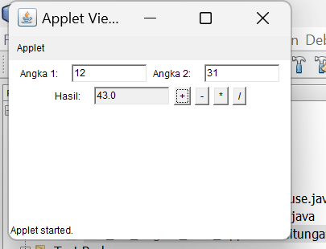

**Script Code:**

/*

* To change this license header, choose License Headers in Project Properties.

* To change this template file, choose Tools | Templates

* and open the template in the editor.

*/

import java.applet.Applet;

import java.awt.*;

import java.awt.event.*;

/**

*

* @author Muhammad Rizal Nur F

*/

public class BP1_M2_Tugas1_Rizal_AppletePerhitungan extends Applet implements ActionListener {

TextField input1, input2, result;

Button add, subtract, multiply, divide;

/**

* Initialization method that will be called after the applet is loaded into

* the browser.

*/

public void init() {

input1 = new TextField(10);

input2 = new TextField(10);

result = new TextField(10);

result.setEditable(false);

add = new Button("+");

subtract = new Button("-");

multiply = new Button("*");

divide = new Button("/");

add.addActionListener(this);

subtract.addActionListener(this);

multiply.addActionListener(this);

divide.addActionListener(this);

add(new Label("Angka 1:"));

add(input1);

add(new Label("Angka 2:"));

add(input2);

add(new Label("Hasil:"));

add(result);

add(add);

add(subtract);

add(multiply);

add(divide);

}

@Override

public void actionPerformed(ActionEvent e) {

try {

double num1 = Double.parseDouble(input1.getText());

double num2 = Double.parseDouble(input2.getText());

double hasil = 0;

if (e.getSource() == add) {

hasil = num1 + num2;

} else if (e.getSource() == subtract) {

hasil = num1 - num2;

} else if (e.getSource() == multiply) {

hasil = num1 * num2;

} else if (e.getSource() == divide) {

if (num2 != 0) {

hasil = num1 / num2;

} else {

result.setText("Error: Division by zero");

return;

}

}

result.setText(String.valueOf(hasil));

} catch (NumberFormatException ex) {

result.setText("Input tidak valid");

}

}

// TODO start asynchronous download of heavy resources

// TODO overwrite start(), stop() and destroy() methods

}

**Analisis:**

Program ini menggunakan TextField untuk menerima input angka dan menampilkan hasil.

Empat tombol digunakan untuk operasi aritmatika: penjumlahan (+), pengurangan (-), perkalian (*), dan pembagian (/).

Hasil perhitungan ditampilkan di TextField hasil, dan kesalahan input atau pembagian oleh nol ditangani.

1. **BP1_M2_Tugas2_Rizal_AppleteAnimasi**

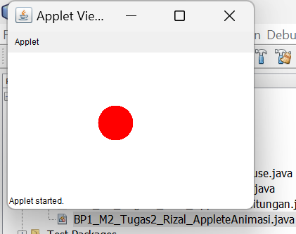

**Script Code :**

/*

* To change this license header, choose License Headers in Project Properties.

* To change this template file, choose Tools | Templates

* and open the template in the editor.

*/

import java.applet.Applet;

import java.awt.*;

/**

*

* @author Muhammad Rizal Nur F

*/

public class BP1_M2_Tugas2_Rizal_AppleteAnimasi extends Applet implements Runnable {

private int x = 0;

private int dx = 2;

private Thread animasiThread;

/**

* Initialization method that will be called after the applet is loaded into

* the browser.

*/

@Override

public void init() {

setBackground(Color.white);

}

@Override

public void start() {

animasiThread = new Thread(this);

animasiThread.start();

}

@Override

public void run() {

while (true) {

x += dx;

if (x < 0 || x > getWidth() - 50) {

dx = -dx;

}

repaint();

try {

Thread.sleep(50);

} catch (InterruptedException e) {

e.printStackTrace();

}

}

}

@Override

public void paint(Graphics g) {

g.setColor(Color.red);

g.fillOval(x, getHeight() / 2 - 25, 50, 50);

}

@Override

public void stop() {

animasiThread = null;

}

// TODO start asynchronous download of heavy resources

// TODO overwrite start(), stop() and destroy() methods

}

**Analisis :**

Lingkaran Digambar yang berwarna merah pada posisi x yang berubah seiring waktu untuk menciptakan animasi, dx menentukan kecepatan gerak dan arah lingkaran.

Ketika lingkaran mencapai batas kanan atau kiri, arah geraknya dibalik, membuatnya bergerak bolak-balik.